**Task – 02: Business Questions**

1. **What is the total gross revenue?**

SELECT

SUM(gross_revenue) AS total_gross_revenue

FROM fact_transaction;

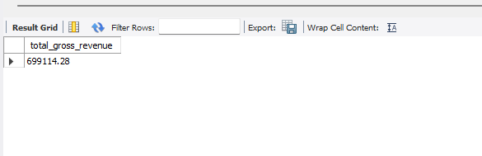

1. **What is the total net revenue?**

SELECT

SUM(net_revenue) AS total_net_revenue

FROM fact_transaction;

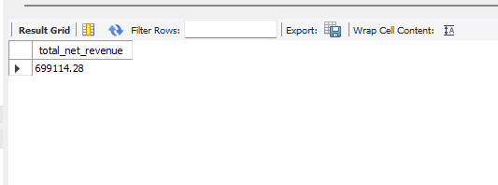

1. **What is the total profit?**

SELECT

SUM(profit) AS total_profit

FROM fact_transaction;

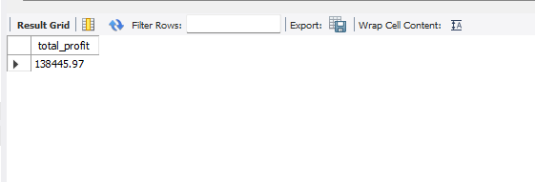

1. **How many orders were placed by each customer segment?**

SELECT

customer_segment,

COUNT(DISTINCT order_id) AS total_orders

FROM fact_transaction

GROUP BY customer_segment;

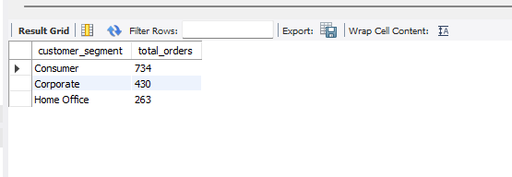

1. **What are the top 5 best-selling products by quantity?**

SELECT

dp.product_name,

SUM(ft.quantity) AS total_quantity

FROM fact_transaction ft

JOIN dim_product dp ON ft.product_sk = dp.product_sk

GROUP BY dp.product_name

ORDER BY total_quantity DESC

LIMIT 5;

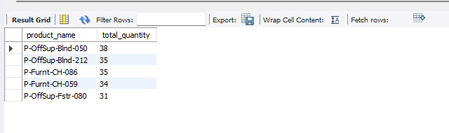

1. **What is the monthly gross revenue trend for 2015?**

SELECT

DATE_FORMAT(order_date, '%Y-%m') AS month,

SUM(gross_revenue) AS monthly_gross_revenue

FROM fact_transaction

WHERE YEAR(order_date) = 2015

GROUP BY month

ORDER BY month;

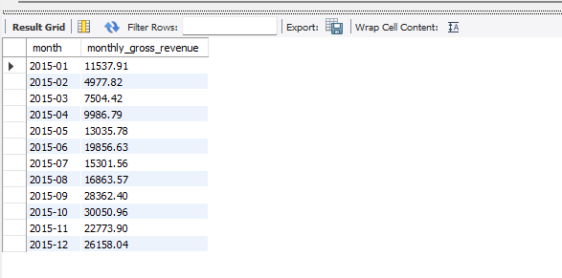

1. **Which sub-category has the highest profit margin?**

SELECT

dsc.sub_category_name,

ROUND(SUM(profit) / SUM(net_revenue) * 100, 2) AS profit_margin_pct

FROM fact_transaction ft

JOIN dim_product dp ON ft.product_sk = dp.product_sk

JOIN dim_sub_category dsc ON dp.sub_category_id = dsc.sub_category_id

GROUP BY dsc.sub_category_name

ORDER BY profit_margin_pct DESC

LIMIT 1;

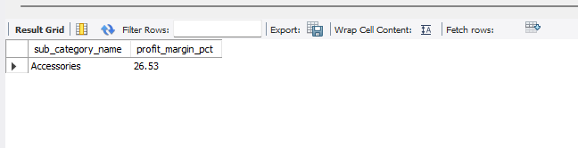

1. **Which continents experience the most product returns as a percentage of total products sold?**

SELECT

dl.continent,

ROUND(SUM(CASE WHEN return_flag = 1 THEN 1 ELSE 0 END) * 100.0 / COUNT(DISTINCT ft.order_id), 2) AS return_percentage

FROM fact_transaction ft

JOIN dim_location dl ON ft.location_id = dl.location_id

GROUP BY dl.continent;

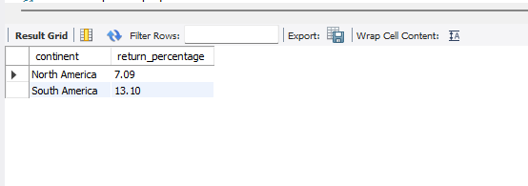

1. **Which products have a negative profit?**

SELECT

dp.product_name,

SUM(profit) AS total_profit

FROM fact_transaction ft

JOIN dim_product dp ON ft.product_sk = dp.product_sk

GROUP BY dp.product_name

HAVING total_profit < 0;

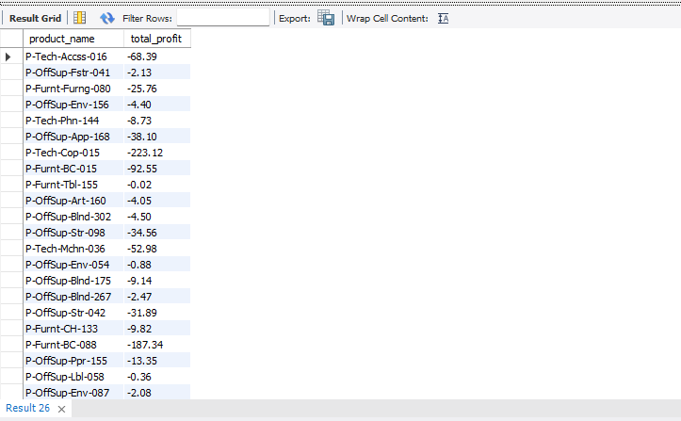

1. **How does discount percentage correlate with order volume?**

SELECT

discount_pct,

COUNT(*) AS order_count

FROM fact_transaction

GROUP BY discount_pct

ORDER BY discount_pct;

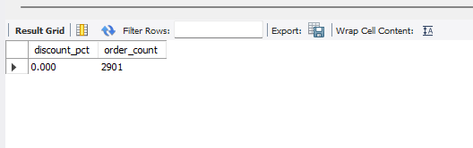

1. **What is the return rate by product category?**

SELECT

dc.category_name,

ROUND(SUM(CASE WHEN return_flag = 1 THEN 1 ELSE 0 END) * 100.0 / COUNT(DISTINCT ft.order_id), 2) AS return_rate_pct

FROM fact_transaction ft

JOIN dim_product dp ON ft.product_sk = dp.product_sk

JOIN dim_sub_category dsc ON dp.sub_category_id = dsc.sub_category_id

JOIN dim_category dc ON dsc.category_id = dc.category_id

GROUP BY dc.category_name;

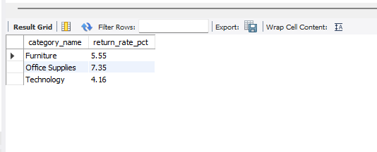

1. **Which shipping mode is most profitable?**

SELECT

ship_mode,

SUM(profit) AS total_profit

FROM fact_transaction

GROUP BY ship_mode

ORDER BY total_profit DESC

LIMIT 1;

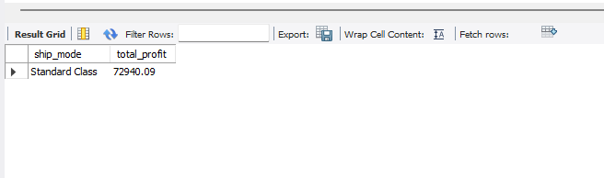

1. **What percentage of orders are high priority?**

SELECT

ROUND(SUM(CASE WHEN order_priority = 'High' THEN 1 ELSE 0 END) * 100.0 / COUNT(*), 2) AS high_priority_pct

FROM fact_transaction;

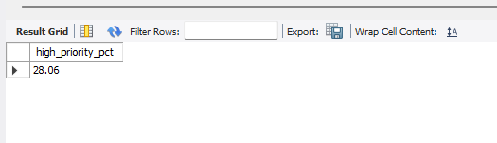

1. **Which city generates the highest revenue per order?**

SELECT

dl.city,

ROUND(SUM(net_revenue) / COUNT(DISTINCT ft.order_id), 2) AS revenue_per_order

FROM fact_transaction ft

JOIN dim_location dl ON ft.location_id = dl.location_id

GROUP BY dl.city

ORDER BY revenue_per_order DESC

LIMIT 1;

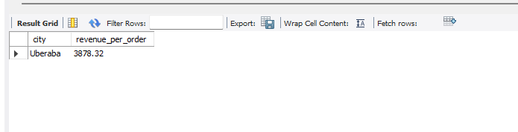

1. **What is the average profit per customer segment?**

SELECT

customer_segment,

ROUND(AVG(profit), 2) AS avg_profit

FROM fact_transaction

GROUP BY customer_segment;

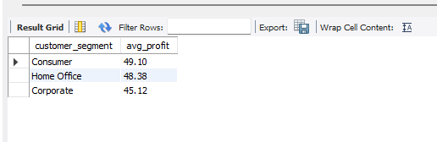

1. **What is the year-over-year (YoY) revenue growth by category?**

SELECT

dc.category_name,

YEAR(order_date) AS year,

SUM(net_revenue) AS revenue,

LAG(SUM(net_revenue)) OVER (PARTITION BY dc.category_name ORDER BY YEAR(order_date)) AS prev_year_revenue,

ROUND((SUM(net_revenue) - LAG(SUM(net_revenue)) OVER (PARTITION BY dc.category_name ORDER BY YEAR(order_date))) * 100.0 / LAG(SUM(net_revenue)) OVER (PARTITION BY dc.category_name ORDER BY YEAR(order_date)), 2) AS yoy_growth_pct

FROM fact_transaction ft

JOIN dim_product dp ON ft.product_sk = dp.product_sk

JOIN dim_sub_category dsc ON dp.sub_category_id = dsc.sub_category_id

JOIN dim_category dc ON dsc.category_id = dc.category_id

GROUP BY dc.category_name, YEAR(order_date);

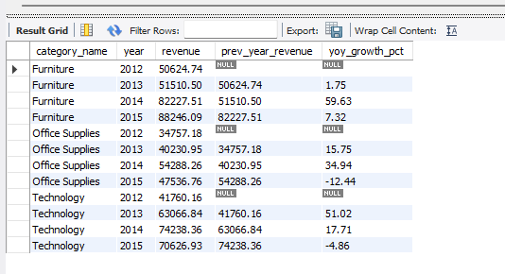

1. **Which products are frequently purchased together?**

SELECT

a.product_name AS product_1,

b.product_name AS product_2,

COUNT(*) AS times_bought_together

FROM (

SELECT order_id, product_sk FROM fact_transaction GROUP BY order_id, product_sk

) o1

JOIN (

SELECT order_id, product_sk FROM fact_transaction GROUP BY order_id, product_sk

) o2 ON o1.order_id = o2.order_id AND o1.product_sk < o2.product_sk

JOIN dim_product a ON o1.product_sk = a.product_sk

JOIN dim_product b ON o2.product_sk = b.product_sk

GROUP BY product_1, product_2

ORDER BY times_bought_together DESC

LIMIT 10;

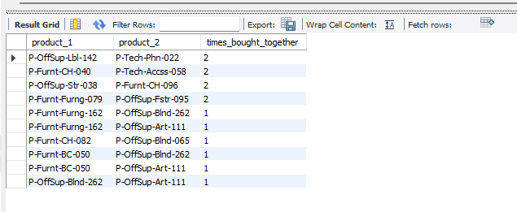

1. **What percentage of orders contain multiple products?**

SELECT

ROUND(SUM(CASE WHEN product_count > 1 THEN 1 ELSE 0 END) * 100.0 / COUNT(*), 2) AS multi_product_order_pct

FROM (

SELECT order_id, COUNT(DISTINCT product_sk) AS product_count

FROM fact_transaction

GROUP BY order_id

) t;

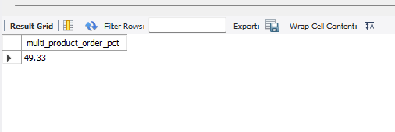

1. **Which orders have abnormally high shipping costs?**

SELECT

order_id,

unit_ship_cost,

quantity

FROM fact_transaction

WHERE unit_ship_cost > (SELECT AVG(unit_ship_cost) + 2 * STD(unit_ship_cost) FROM fact_transaction);

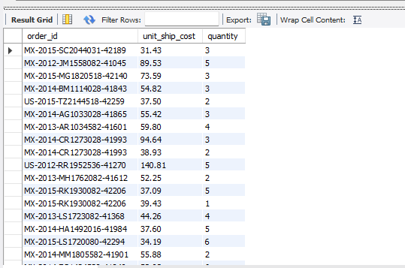

1. **How are orders distributed by value segments (Low/Medium/High)?**

SELECT

order_id,

CASE

WHEN net_revenue < 100 THEN 'Low'

WHEN net_revenue BETWEEN 100 AND 500 THEN 'Medium'

ELSE 'High'

END AS value_segment,

net_revenue

FROM fact_transaction;

